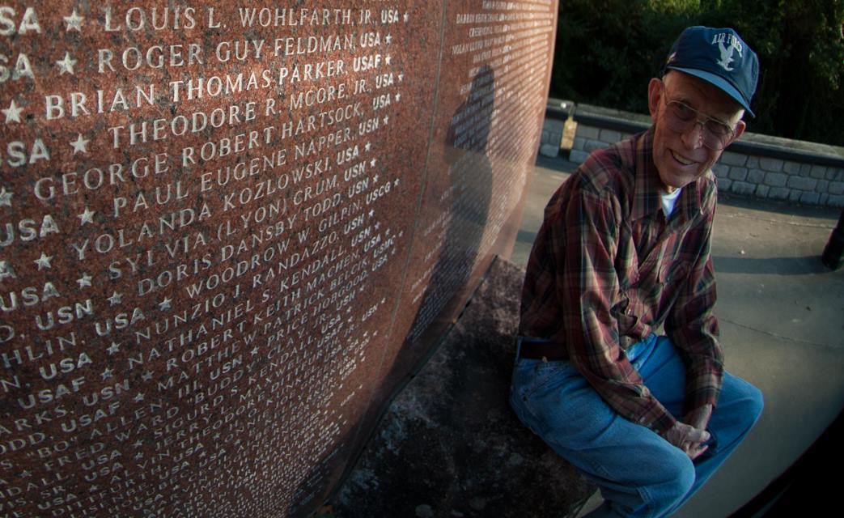
Lieutenant Colonel Brian Parker came from Baltimore, where he attended the University of Maryland on a track scholarship after high school...and it was there that an ROTC instructor guided him on the path that would lead to a distinguished 20-year military career.
"Sergeant Bloom at the ROTC detatchment approached me and he said they're forming a new Air Force Academy, would you like to apply for that? And I said 'why not?'...and that's where the story started."
Parker attended the Air Force Academy and was a member of the first graduating class in the school's history. While at the Academy, he discovered the 13th bomb squadron on a field trip and decided he wanted to be a part of that.
"Yes, we took a field trip of all the far eastern bases and the unit we went to was the 13th bomb squadron - and it was B57's. So when I finished the advanced nav bomb training at the Nather air force base after graduation, I had a choice: B-52's or B-57's. And I said give me the B-57's."
Parker flew B-57's for 4 years, but after one of his friends was taken a prisoner of war, he volunteered to go back to flying B-57's again. However, due to a mix up in personnel, he was instead assigned to the AC-47, but as he'll tell you, it was a blessing in disguise.
"It turns out it was one of the best assignments I ever got...we saved lives. We flew at night, we went out to camps, Vietnamese camps, villages, army posts, and they were just crying for help and once we got there, we never lost a camp."
From June 1966 to January 1968, Parker flew on AC-47's, defending U-S outposts and forts from enemy soldiers in Vietnam.
"We'd lay the smoke on the ground and we'd positively identify the target, I would tell the pilot you're on the target, you're clear to fire. They'd rock the wing a little bit and cover the whole area. Sometimes the people on the ground would yell, "glad you're here." They'd breach the fence, they're swarming all over us, we're all undercover, fire on the camp...and we did. And we just kind of would sweep off the bad guys...and that was the end of the engagement for the night."
Brian Parker will tell you that he considers his experience in Vietnam very rewarding and feels fortunate to have made it back home safely.
"Well, we did the best we could...we did not make national policy. We were assigned to do a job, and we did the best we could. I felt mine were very rewarding in the B-57's we were fighting the cold war. We stood alert over in korea because of the status of forces agreement with Japan and that was very rewarding. We were on alert going to Kennedy assassination and the Cuban crisis. We thought we were going several times, the gates were opened several times, which meant we were going, but before we actually got there, they closed them, and we heaved a sigh of relief. That was very rewarding. But we didn't expect to come back. We didn't have enough fuel to come back. We were going down somewhere along the way home. And hope we made it and hopefully there was something back here after we finished."

