Frank P. Bender
Colonel, United States Air Force

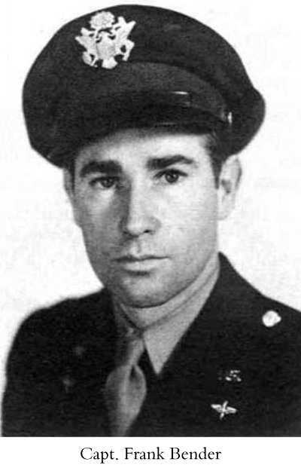
Apr 25, 1916 - May 5, 2003

Frank P. Bender, a veteran of U.S. defeats on Bataan and Corregidor in the Philippines during World War II whose plane was shot down twice in Papua New Guinea, died Friday. He was 87.
A native of Brooklyn, New York, Bender earned a degree in economics from Hobart College in Geneva, New York. He enlisted in the Army Air Corps in 1939 and was commissioned in 1940.
"He always wanted to be a pilot," said his wife, Norma Nicholson Bender of Houston.
Bender was at Clark Field in the Philippines when Japanese planes attacked shortly after the assault on Pearl Harbor in December 1941. On Christmas Eve of that year, he was evacuated by boat to Bataan and later sent to Corregidor.
From Corregidor, Bender went by submarine to Java. After the Japanese invasion of Java, he escaped by flying to Australia.
In subsequent combat, Japanese aircraft twice shot down his planes over Papua New Guinea, with Bender being listed as missing in action both times. In both cases, natives, settlers and missionaries helped him reach Port Moresby.
After the war, Bender served in the Strategic Air Command, ending his military career in 1965 as commander of the Heavy Bombardment Wing at Bergstrom Air Force Base in Austin.
Bender was named project director of the Galveston Bay Study in 1967 to determine whether government water quality standards were sufficient to decrease pollution in the bay.
After completion of the project, Bender joined the International Polymer Corp. of Houston as manager of government contracts. He retired in 1997.
Besides his wife, Bender leaves two daughters, Cherie Todd of Savannah, Georgia, and Patti Day of Houston; and a sister, Grace Surgeon of Ocala, Florida.
Services will be at 11 a.m. today at Christ Church Episcopal Cathedral, 1117 Texas. Burial will be in Arlington National Cemetery.

