James Harrison Mangan Sr.

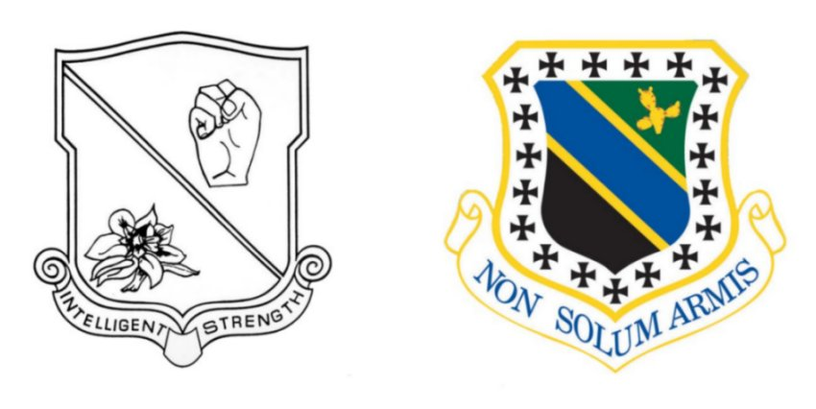
James Harrison Mangan, Sr., an officer in the 27th Bombardment Group (L), 17th Squadron, and 3rd Bombardment Group, 13th Squadron, passed away on April 21, 2009 and will be buried at Arlington National Cemetery on August 12, 2009.
Harry Mangan began USAAC flight training at the Dallas School of Aviation in 1940 and graduated at Kelly Field. He sailed for the Philippines with the 27th BG aboard the President Coolidge and arrived in Manila on November 20, 1941. He was one of the pilots who was ordered to Australia to re-assemble the 27th Bomb Group's A-24 dive bombers that had been diverted to Brisbane at the outbreak of the Pacific war. Lt. Mangan was also co-pilot aboard one of the B-25C aircraft (#41-12472) that participated in the Royce Special Mission to the Philippines in April, 1942. He was one of few survivors of "The Old 27th" to return to the United States in October, 1942. Colonel Mangan retired from the USAF in 1965.
Harry shared his firsthand knowledge willingly in later years, as is evidenced in Martin and Stephenson's 2008 book, Operation PLUM, The Ill-Fated 27th Bombardment Group and the Fight for the Western Pacific. His wartime diary and his sharp memory of the early, chaotic days of the war in the Pacific were tremendous resources for those of us always interested in learning more.

