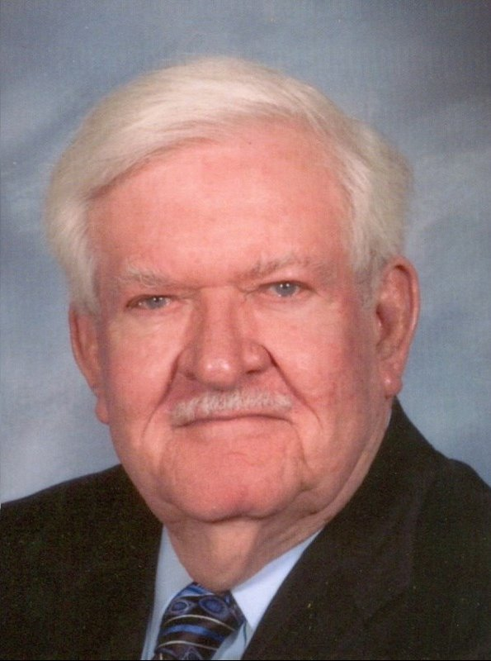

Otto Albert Rees, age 85, passed away peacefully on May 31, 2014, surrounded by his loving family and friends. Beloved husband of 58 years to Thelma Vogt Rees. Loving father of Michael Albert Rees and father-in-law of Susan Seuzeneau Rees. Loving grandfather of Michelle Leigh Rees. Brother of Mary Rees Cornibe. Son of the late Otto J. Rees and Katie R. Rees. Son-in-law of the late John P. Vogt, Sr. and Thelma B. Vogt. Brother-in-law of the late John P. Vogt, Jr., Gladys K. Vogt and Emmett C. Cornibe. Survived by many nieces, nephews and cousins. Mr. Rees was a native of New Orleans, LA and a resident of Kenner, LA. He was a graduate of Jesuit High School and LSU, where he earned a degree in Chemical and Civil Engineering. He worked for South Central Bell, and later AT&T, before retiring. Mr. Rees was an Air Force veteran, 90th Bomber Squadron-Paradice, proudly serving his country as a pilot in the Korean War.

