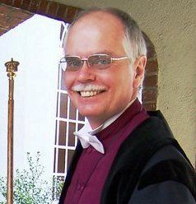

Patrick Sullivan Conn, 67, of Pennton Avenue, Lenoir, formerly of Memphis, Tenn., Lexington, Ky., St. Petersburg, Fla., Knoxville, Tenn., and West Lafayette, Ind., passed away Saturday, Sept. 26, 2015, at his residence. He was born Aug. 19, 1948, in Memphis, Tennessee, to Celeste Taylor Conn of St. Petersburg, Florida, and the late John Curd Conn Sr.
Dr. Conn was a graduate of University of Tennessee (Knoxville) and Southern College of Optometry (Memphis). He retired from practicing optometry in Lenoir, Valdese, and Morganton for approximately 30 years before pursuing post-retirement career of teaching science and math at South Caldwell High School and The Patterson School. He was passionate about music, science, loved his family and the Episcopal Church.

