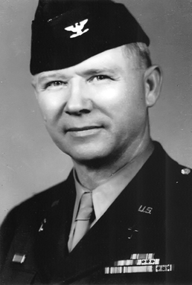
Edgar R. Cochrun, Chaplain
Base Section #2
U.S.A.F.I.A.
1942
During World War II, my grandfather served both in the Pacific and in Europe after the invasion. His service in the Pacific began in 1942 when he sailed aboard the USAT Ancon to Adelaide, Australia. He arrived in Australia May 14, 1942.
While in Australia he maintained two records, a diary (which sadly was not always well maintained) and a list of men whose lives were lost during the war. I recently ran across that latter notebook and thought perhaps there were those who would like to see the names of the men at whose funerals he officiated. According to a note at the beginning of the record he sometimes also officiated at Jewish funerals.
Elmer F. Beckett

2nd Lieut. Theron G. Platt - Pilot
Third Bombardment Group
3 November 1942 American Cemetery Port Moresby
(Mother) Mrs. A.R. Platt The Oaks L.I. N.Y.
Died in plane crash following mission over enemy territory 2 November 1942. Landing gear of plane shot off by enemy fire.
(Letter of condolence sent)
Sgt. Harris H. Coffey – Upper Gunner
Third Bombardment Group
3 November 1942 American Cemetery P. Moresby
Wife Mrs. Bessie M. 307 E. Pk. A Savannah, GA
(letter of condolence sent)
Died in plane crash following mission over enemy territory 2 November 1942. Landing gear of plane shot off by enemy fire.

S/Sgt Richard C. Frankforther - Bombardier
Townsville, N (illegible)
Died of injuries about Nov 8-10, 1942, of injuries (sic) received in a plane wreck (see under Lt. Platt). I attended this soldier at hospital before he was taken back. He showed very great courage. (Mother) Mrs. Naomi Frankforther
(Letter of condolence sent)
516 Conant St.
Maumee, Ohio
Letter of condolence sent (3rd Bomb. Gp.)
(It is unknown if the two entries regarding letter of condolence means the 3rd. Bomb. Gp. also sent a letter).
Sgt. Gilliam R. Mefford - Radio Gunner
Third Bombardment Group
3 November 1942 American Cemetery P. Moresby
Mrs. Rosa Ellen Mefford (Mother) Route 8 Springfield, Tenn.
Died in plane crash following mission over enemy territory 2 November 1942. Landing gear of plane shot off by enemy fire.
(Letter of condolence sent)

