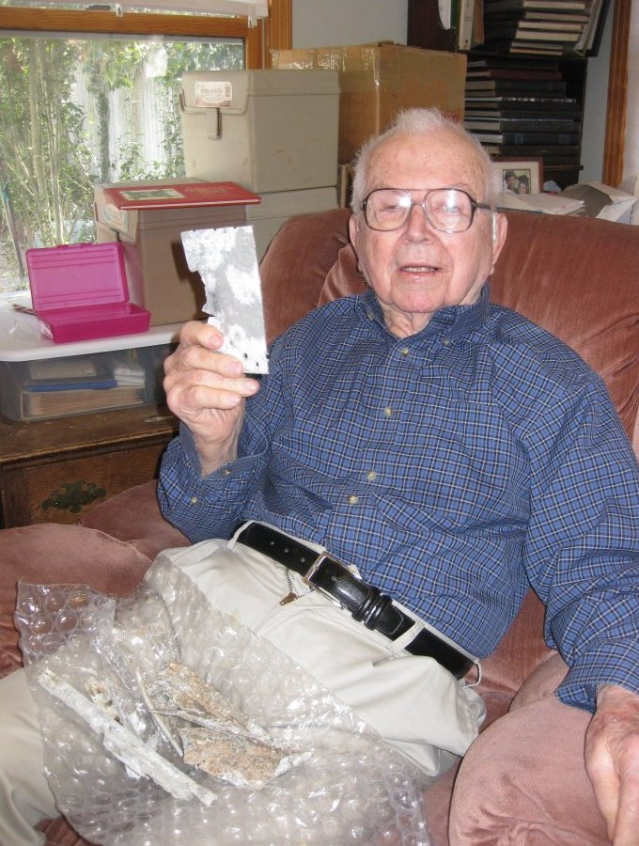

Garland John Robinson, proud son of the Houston Heights, died peacefully in Austin on May 29, 2014, twelve days short of his 97th birthday. He was born to Dr. Guffie Jefferson Robinson and his wife Neva in the Houston Heights on June 10, 1917, the fourth of seven children. He attended Cooley School and John Reagan High School, and was an all-city guard on the 1934 Bulldog football team. Dr. Robinson started his career in the Heights as a horse-and-buggy doctor, and one of John's earliest memories was driving his father on his rounds in his Model T. John attended Rice Institute and the University of Houston, graduating with an engineering degree. As a grandson of a civil war veteran, he proudly served in World War II in the Army Air Force, 89th Squadron, Third Bomb Group, as an Engineering Officer. He was stationed in New Guinea for over two years, miraculously maintaining a fleet of aging A-20s and B-25s during some of the fiercest fighting of the Pacific War, and for those heroic efforts, he was awarded the Legion of Merit for "exceptionally meritorious conduct in the performance of outstanding services and achievements." After his retirement, he organized the first reunion of the 89th Squadron, which was held in Austin and soon became an annual event. He knew in his heart that the efforts of the 89th Squadron led directly to ending the war.
Returning to Houston he married the love of his life, Marjorie Stephens Kilpatrick, in Memphis, Tennessee, a marriage that lasted almost 60 years until her death in 2004. They had six children: Katy, Tom, Jim, Allen, Mary and Bill and lived in the Spring Branch area of Houston. John ran his own general building contractor business for over thirty years, specializing in later years in historic home restoration. Some projects include the historic homes in Sam Houston Park in Houston and the George Ranch Historic Park near Richmond.
As his parents and grandparents had been charter members of Heights Presbyterian Church in the Heights, John and Marjorie were charter members of Spring Branch Presbyterian Church in Houston. Life revolved around family and church. John's life was one dedicated to service; to his family, to his church and to whoever needed his assistance. If there was work to be done, John was often the one who did it. John exemplified the life of the servant of the church, dedicating his retirement to helping others. After moving to Austin in the mid-1980s John and Marjorie became active in Central Presbyterian Church in downtown Austin, and spent several months each spring volunteering his construction skills at Mo-Ranch in the Texas hill country.
Today we know that he is holding hands with Marjorie, telling her about his day, she's responding into his good ear about a new bookstore she needs to visit, and together singing the song that was sung every night at the dinner table, "Blest be the tie that binds; our hearts in Christian love; the fellowship of kindred minds; is like to that above."
He is survived by his six children, twenty-two grandchildren and nineteen great-grandchildren.

