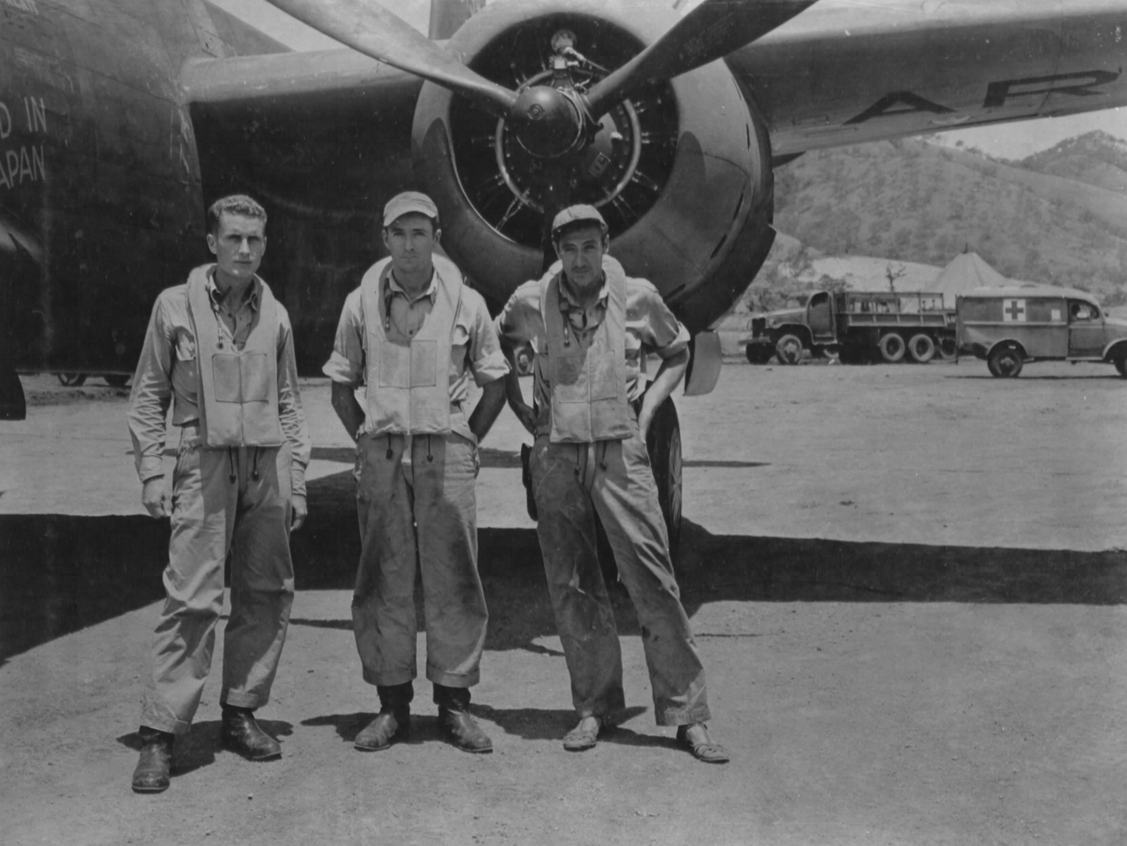
Prior to his service with the 409th Bomb Group, Capt Roger D. Dunbar flew A-20s with 89th Attack Squadron 3rd Attack Group in Australia & New Guinea.

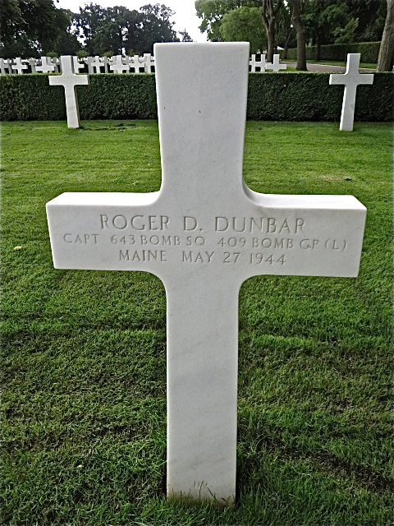

Casualty of WWII, Roger was the pilot, one of the four man crew of a Douglas A-20J Havoc which had just taken off from runway 16 at Little Walden airfield in Essex, England. He entered the service from Maine and his Service # was O-431268.They served in 643 Bomb Squadron, 409 Bomb Group. His comrades were First Lieutenant Norman W Merrill , Bombardier and Navigator, First Lieutenant William B Jones Photographic Officer and Staff Sergeant and turret-gunner Angelo A Mattei
About four and a half hours after the first plane returned from the first mission, the group was in the air again. Minor repairs had been made, planes serviced, crews fed and briefed. Due to much battle damage and loss of planes, only 35 aircraft were serviceable for the second mission.
They were to attack the railway marshalling yards at Amiens in France. At the same time a formation of Mustangs had taken off from Fowlemere flying into the sun. The trailing fighter,piloted by Second Lieutenant Robert L Dickens in P-51B 42-106907 collided with the leading Havoc and both machines crashed in flames at Puddle Wharf Farm, Ashdon in Essex. It was about six o'clock in the evening. George Everitt, the farmer had died the year before and his widow, Elizabeth Ann Everitt,
mother of a four year old son,raced to the scene and with the help of a USAAF airman Sergeant John P Hartman,who was cycling in the vicinity, she managed to extricate Angelo Mattei and move him to safety. On returning to the wreck with Sergeant Hartman, the bomb load exploded killing them both, and the three crew members remaining in the aircraft. Elizabeth Everitt was posthumously awarded the Albert Medal for her gallantry.
Norman Merrill was initially interred at Cambridge Cemetery where Captain Dunbar and First Lieutenant Jones still rest. Angelo Mattei survived the war and lived to 74 years.
Awards: Distinguished Flying Cross, Air Medal with 2 Oak Leaf Clusters, Purple Heart.

