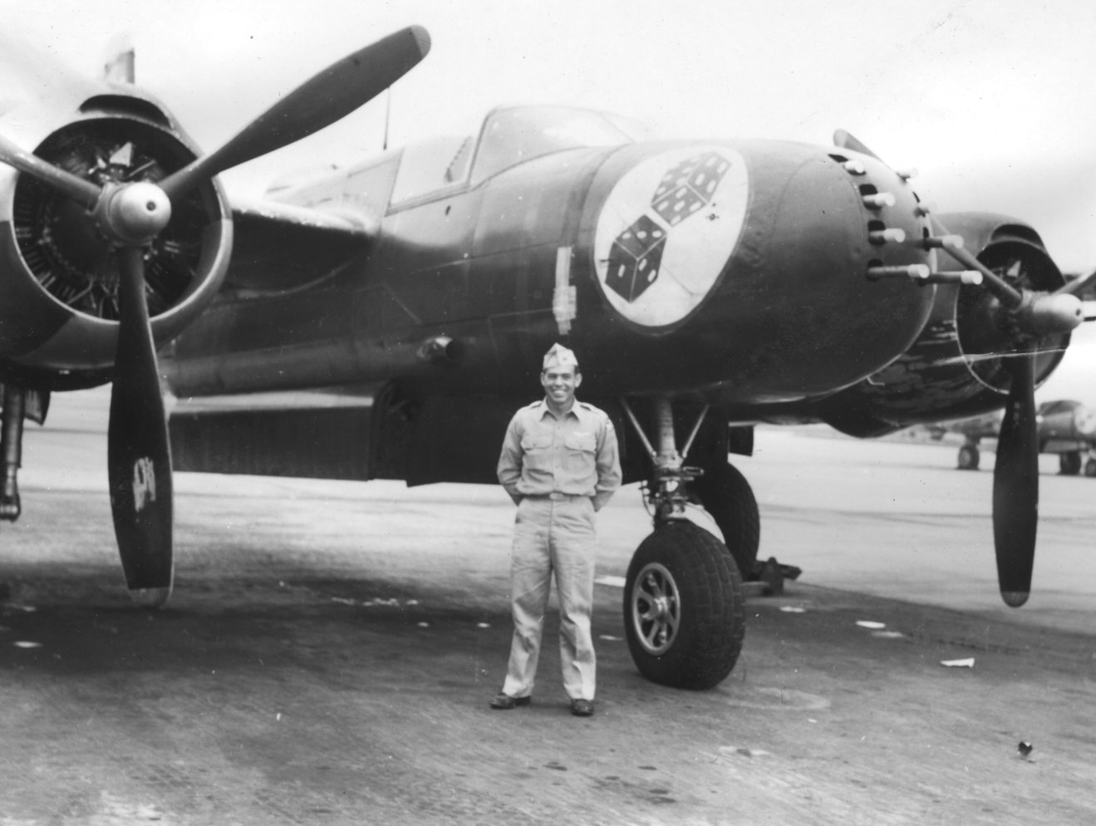
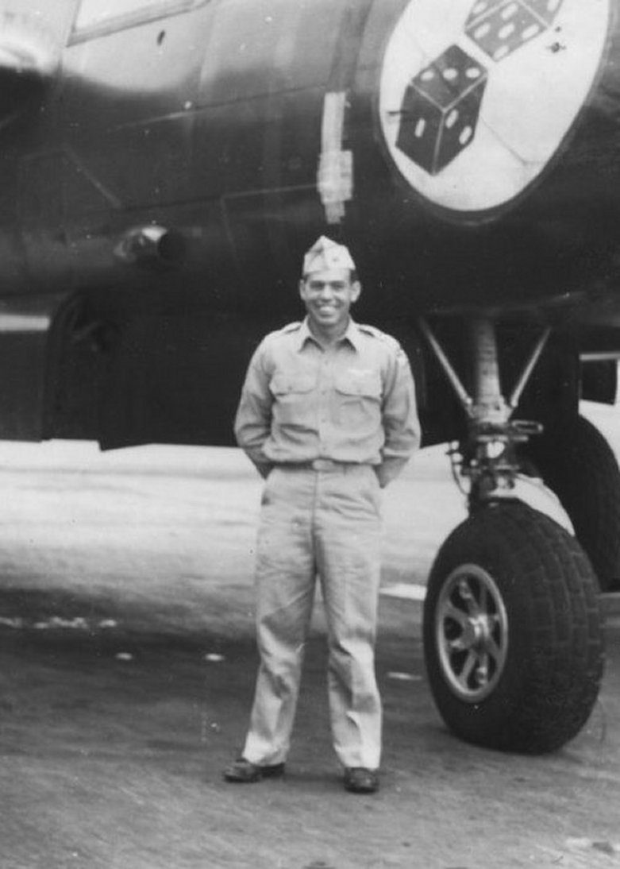

Abraham E. Shook (1920-2014)

Abraham "Ed" Shook went to be with our Lord on February 25, 2014 in San Antonio, TX. Born May 27, 1920 in Plain, NM, he lived a full life and was a loving husband, father, grandfather, and great grandfather.
After 26 years of active military duty, serving in WWII, and the Korean war, he retired as an Air Force Colonel in 1966 with many accomplishments and awards, including the Silver Star, the Legion of Merit, and Distinguished Flying Cross. He is also credited with designing the Shook Bomb which was an integral part of the low level bomb attacks during the Korean War.
Ed is preceded in death by his wife, Virginia Shook, son, Ronald Shook, daughter, Kathy Hollis, grandson, Trey Oliver, parents, Fate and Wilma Shook, 5 brothers, and 1 sister.
He is survived by his daughters Donna Dee (Jim), Susan Ray Martin (Robert), his son-in-law Charles Hollis, his granddaughters Leeann Miracle (Bill), Kimberly Odom (Matt), Amie Iverson (Justin), Carrie Moore, his grandson Don Arthur, and 11 great grandchildren.
He will be laid to rest at the Arlington National Cemetery in Arlington, VA.

