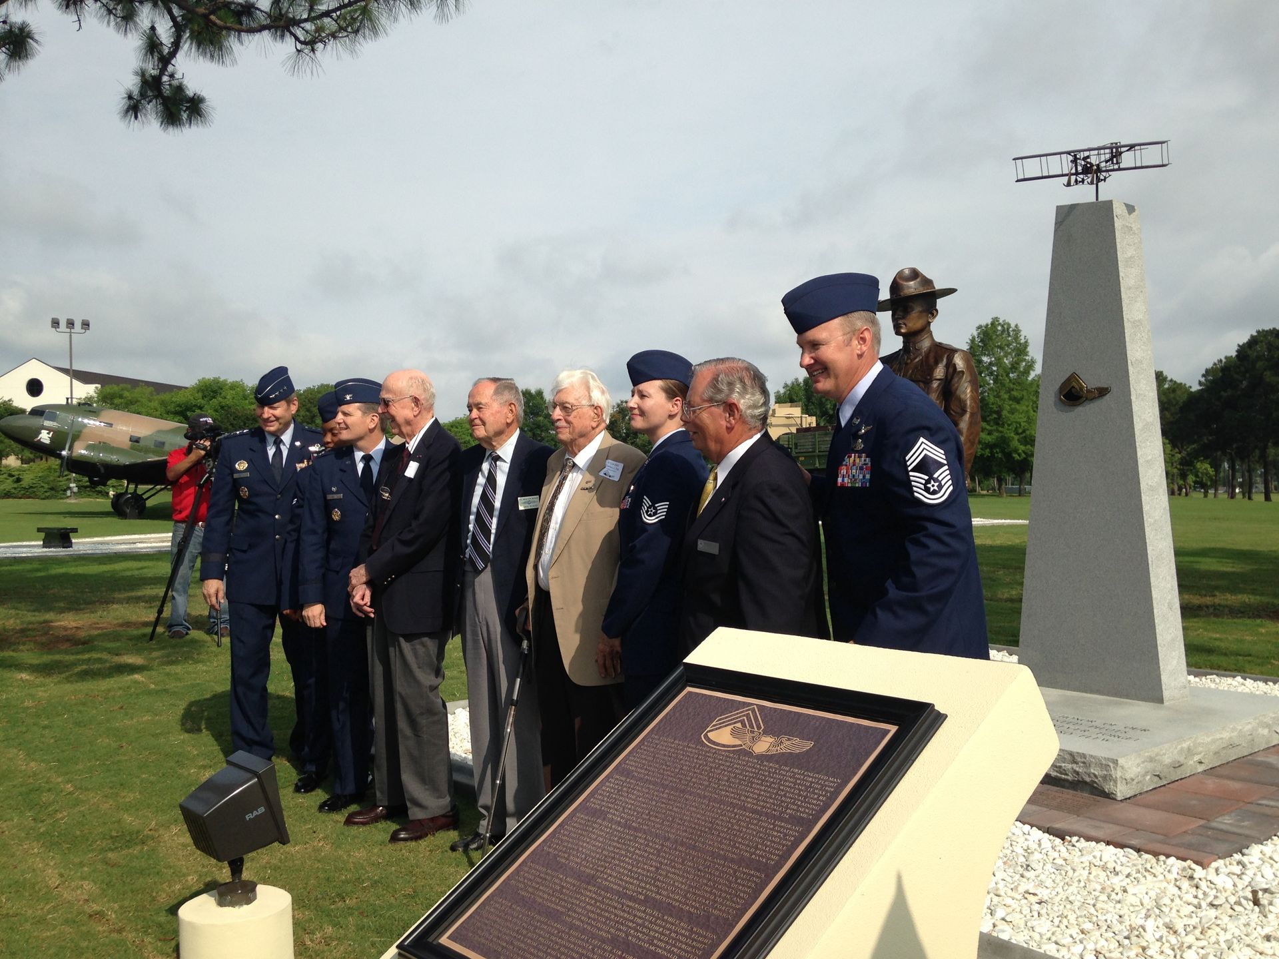
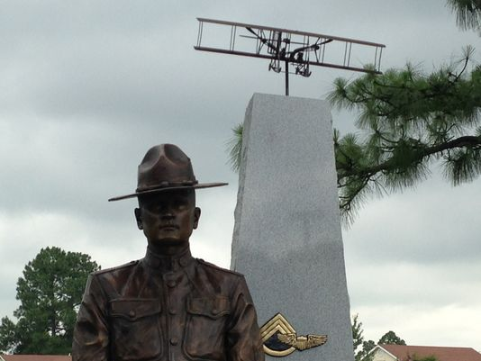

Thousands of American military men proved an officer's rank wasn't essential to do battle in the skies during World Wars I and II. They were honored this week with a monument at Gunter Annex in Montgomery.
A large crowd of Air Force enlisted personnel and officers turned out Monday for the unveiling of the Enlisted Pilots of the Air Force Monument.
Traditionally, only officers could be military pilots, but during the World War I and World War II, when there was a pilot shortage, the Sergeant Pilots program allowed about 3,000 enlisted personnel to train at flying schools and pilot almost every type of aircraft.
Three of the men who began their careers as Sergeant Pilots were present at the ceremony — retired Col. James P. "Pat" Pool, retired Lt. Col. John W. Beard and retired Lt. Col. Charles L. Fisk.
Fisk, who graduated pilot school and flew 53 combat missions in a B-25, attended the event with his family.
"I don't have enough words to describe it, really," Fisk said. "It's wonderful. It's great to be here and see everybody."
Beard flew 105 combat missions and three consecutive combat tours over North Africa, China and India.
"It's the most impressive thing I've ever been connected with, really," Beard said.
Pool flew cargo and soldiers to battlefields in the Pacific Theater and took part in the Berlin Airlift, which took place in 1948 and 1949.
During the ceremony, he shared humorous stories of his time as a pioneer pilot. He ended his speech on a serious note.
"I'd like to close this celebration by remembering the motto of the Sergeant Pilots: 'We few, we happy few, we band of brothers," Pool said.
Friends and families of Sergeant Pilots who have passed away also attended the ceremony.
Four-star Gen. Robin Rand, commander of Air Education and Training Command, dedicated the monument and saluted Pool, Beard and Fisk for their contributions to military aviation and to all those enlisted pilots serving from 1912 to 1942.
"Our enlisted pilots were the very best our country had to offer, Rand said. "I am honored to be here today to memorialize their service, and I am truly humbled to count myself among them as a United States Air Force military pilot," Rand added.
The monument, sculpted by artist Michael Maiden, depicts the likeness of Corp. Vernon L. Burge, America's first enlisted aviator, standing in front of a marble monument displaying a Wright Flyer replica. It is displayed outside Gunter's Enlisted Heritage Hall and Research Institute, a museum dedicated to preserving the story of enlisted airmen and whose staff was responsible for procuring the monument.

