John Jewell
30 Tulip Street
Aitkenvale 4814
QLD Australia

23rd August 2015

SUBJECT: USA - 94th Coastal Artillery/Anti Aircraft Camp 1942
LOCATION: Lissner Park, Charters Towers, Queensland, Australia

REFERENCES:
- Plan NAA: J153, T331 United States Camps 94th CA/AA
  - E.T. Doig/Lew 29-6-1942
  - Superintendent Eng’r Dept of the Interior Townsville
  - Traced by F.I.P.T. 29-6-42 – T331
- Map: Charters Towers Sheet 8157 (Edition 1) Australia 1:100,000 Topographic Survey
- Charters Towers & Dalrymple Archives Group, courtesy Michael Brumby
- Personal knowledge of Claude Risdale, John Jewell and also of my late brother Jim Jewell who passed away recently. We all lived in Charters Towers during WW2.

ORIENTATION: LISSNER PARK
The Park’s area of 7 hectares (17 acres) is close to the centre of Charters Towers and lies directly under the flight path from the southern end of the 09 Degrees (Magnetic) runway of the Corinda aerodrome where the USAAF 3rd Bombardment Group’s four squadrons were based. Corinda aerodrome is located on the northern edge of Charters Towers.

The Park is rectangular. The longer side’s boundaries are aligned north/south. Church Street is on the eastern side. The shorter Bridge Street, merging into Deane Street, is on the western side. The shorter east/west street along the northern boundary is Plummer with Anne Street along the southern boundary.

Mossman Creek runs through the Park from west to east through Thornborough College grounds, then under the Bridge Street Bridge. It runs close to the northern end of the Park.

OCCUPATION:
5th June 1942. The Regimental HQ and HQ 2nd Battalion of the USA 94th CA/AA arrived in Charters Towers and took over Lissner Park for their base of operations.

According to Plan NAA J153, T331 the composition of batterys and the layout of their amenities in the Park as per this plan are:
- F Battery - 130 men, 4 x 3 inch AA guns, 4 x .50 calibre water cooled machine guns.
- E Battery - 70 men, 12 searchlights (not 15 as 1 platoon short).

F & E Batterys had shared amenities for showers and latrines for 200 men. F Battery had a kitchen/mess for their 130 men. E Battery had a separate kitchen/mess nearby for their 70 men. The amenities were situated in the N/E corner of the Park right on the bank of Mossman Creek. (This would take the runoff from the showers and other grey water.)

Regimental HQ and 2nd Battery HQ had their amenities of showers and latrines for a total of 150 men located close to the western fence with Deane Street. There was a deep gutter outside the fence and footpath. (This would take the runoff from their showers and grey water into Mossman Creek.)

Charters Towers’ famous Boer War Memorial/Kiosk was taken over from the Australian Army (Militia) for their kitchen and mess. It was located fairly central in the Park and almost opposite their amenities near the fence.

Regimental HQ and 2nd Battery HQ Officers took over the Park Hotel for their accommodation. The Park Hotel is on the opposite side of Deane Street and directly across from their 150 man latrine and showers.

NOTE. There is no information shown on the location of G Battery’s amenities on this Plan drawn on 29th June 1942 twenty four days after the occupation of this Park on 5th June 1942. G Battery arrived later. I tend to think their amenities for 130 men were located on the eastern side of the Park fronting Church Street but towards Mossman Creek for the gutter outside the fence to dispose of their shower and grey water into the creek. However as 73 years have since passed I cannot confirm.

F BATTERY’S 4 x .50 calibre water cooled Machine Guns
Jim and my recollections of one particular machine gun
Each of the four 3 inch AA guns was allocated one machine gun. The 2nd Battalion’s four .50 machine gun sections were commanded by the 2nd Battery’s Assistant Executive Officer. Jim and I believe his name was Captain Steele. He once threatened us “I will kick you and your brother’s butts if ever I catch you boys again crawling under the barbed wire fence to the .50 weapon pit”. The pit was located just behind our back fence on vacant land. We visited the gun and crew many times afterwards but kept a sharp lookout for him. The 3 man gun crew consisted of 1 Sergeant (Gun Commander), 1 Corporal (Chief of Ammunition) and 1 Artillery Mechanic. They lived in a tent pitched under a shady tree right beside our back fence. They walked across to Lissner Park for their meals etc. I can recall two names, “Waldair from Wisconsin” and “Dilworth* from Detroit”. Jim and I used to chant their names like a rhyme. Occasionally the Sergeant let us play with their .50 by swinging it around. The gun had a padded hook at the end which the gunner got into to swing the gun around. He actually became an extension of the gun. Jim and I loved swinging it around.

They also dug a cave into one side of the weapon pit where they stored their drums of ammunition. The entrance was covered by a canvas flap. Once they urged me to crawl into it. It was a big mistake on my part as it was not only pitch dark but full of mosquitoes that swarmed all over me. They thought it was a great joke. The tables were turned on them days later. Mother was in our back yard. She heard yells and saw the men jumping out of their pit. Apparently a snake had taken up residence in their cave unknown to them until one reached in for something and touched it. It must have been a harmless carpet snake, not a deadly brown snake. Mother could not stop laughing as she described the action to us.

One very cold evening just after dark Mother became concerned. “Those poor boys must be freezing in their tent. Father, you must do something to help them keep warm”. Poor old Dad was hoarding a small amount of rum in a bottle as alcohol and tobacco were very hard to come by. He handed Jim the bottle and told him to take it to the fence and give it to them. Jim came back loaded with several packets of cigarettes as a thank you. Dad’s eyes lit up saying “I wonder what they would have given me for a full bottle of rum”. It became a family joke for many years.

* My late mother was an avid stamp collector. A Post Card addressed to:
C.M. Dilworth
A.S.N (Army Service Number) 6565651
5691-C-1
A.P.O 1111, c/o Postmaster
San Francisco
California
It is post marked Los Angles JUN 23 11AM 1942. Dilworth gave this card to my mother to add its 1cent stamp to her collection. I now have this Post Card in my possession.

THORNBOROUGH COLLEGE
Thornborough College, opposite Lissner Park, played a very important role in the Anti Aircraft defence of Charters Towers during the period the 94th CA/AA was based there in 1942. Two AA guns were located on the top sports field. The location of one AA gun’s position, within a sandbagged enclosure, was on the edge of the top sports field but not in direct line of sight from our Jewell family house which was situated on the corner of King and Plant Street. I have been given to understand information supplied by ex-WW2 student Norm Wallace, via Claude Risdale, that another 3 inch AA gun was located on the lower sports field that once had been the old Bonny Dundee Dam. I do not have personal knowledge of this gun. I am aware that a .50 machine gun was located on this lower sports field. These three gun crews lived in Lissner Park close by as opposed to the second AA’s gun crew’s separate accommodation. Also on the top sports field was a searchlight. These four guns and searchlight were guarded by sentries to keep curious students away.

The second 3 inch AA gun was located on the northern edge of the sports field. It was situated against the sloping embankment just below where their tennis court used to be right beside Plant Street, opposite Dr Edmeade’s house. Only a semicircle of sandbags was required for protection as the sloping embankment formed the remainder of the encirclement. This gun was clearly visible from our Jewell family house. Its accompanying .50 machine gun was the one near our back fence.

THE OCCUPATION OF Mr BROWN’S HOUSE
The following are extracts from Mr Brown’s recollections, courtesy of CT & Dalrymple Archives Group.
“The Americans landed at Charters Towers. They placed Anti Aircraft guns on playing fields of Thornborough College - 150 yards from my back fence and placed a height finder next door to me, and placed the radar machine in the middle of Queen Street opposite my big gate. Two Officers came to my house early one morning and asked me to put up some American soldiers under the house. I objected and he said if you disagree we will put you out and take over. I agreed. Eighteen men (18) men were placed under the house and three (3) sergeants on the side verandah. They were the battery men who practised firing the Ack Ack guns every Monday. The men ate and had various amenities at Lissner Park. They were very quiet and friendly. They made no noise, always studying.” “To live and see what an ally the USA is, is very rewarding. I feel only for the Yanks that the Japanese would still be here.” End of extracts.

Our close knit immediate neighbourhood, as we all knew the Browns, were shocked by this action. However 1942 being a critical time for North Queensland being so close to New Guinea and the fighting along the Kokoda Track, that’s how it was in those days.

NOTE: Mr Brown’s house was built on high posts. A hessian screen was placed around the outside posts for privacy for the 18 Enlisted Men living under the house. The “3 Sergeants” were actually one Sergeant and two Corporals. The Range Finder and mobile Radar were relocated shortly afterwards. JJ

A STANDARD MANNING
The standard manning of a 3 inch AA gun consisted of:
- The Gun Squad (who lived upstairs on Browns’ verandah)
  - 1 Sergeant - The gun commander
  - 1 Corporal - The gunner
  - 1 Corporal - The fuse setter
- The Enlisted Men (who lived under the house)
  - 1 Azimuth setter
  - 1 Elevation setter
  - 6 Cannoneers
  - 10 The Ammunition squad. TOTAL 21.

This 21 man crew of the 2nd gun had a truck to convey them quickly to their gun position, also to the Park for meals and amenities. They were a friendly group who always waved to us as they drove across the large area of vacant land that extended along Plant Street from our house to Dr Edmeade’s house located on the corner with MacDonald Street opposite the College tennis court.

These AA guns were well positioned for the defence of military installations in and around Charters Towers. This includes the aerodrome as they were directly under the southern approach of the 09 degree (magnetic) runway as well.

Brown’s house today (August 2015) – front and side views 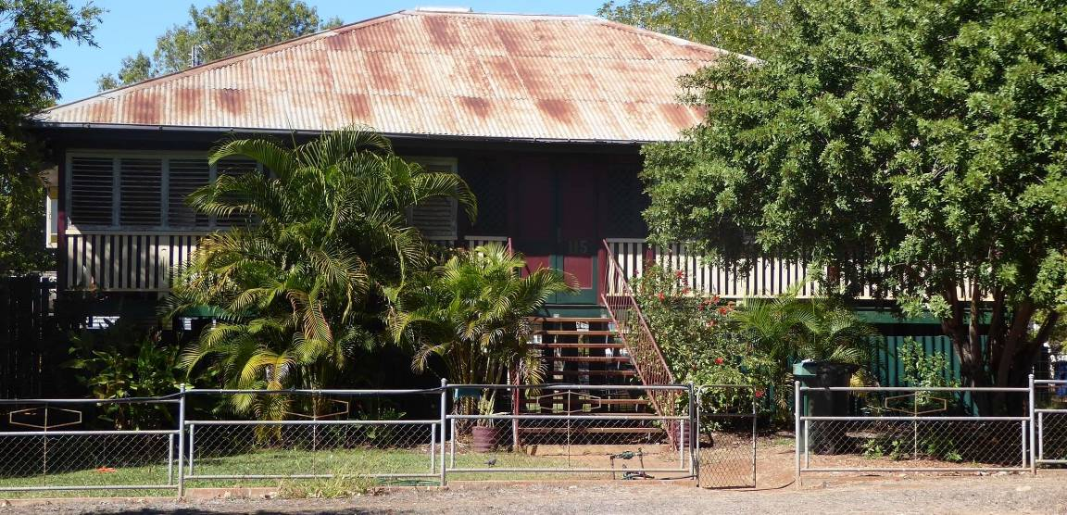
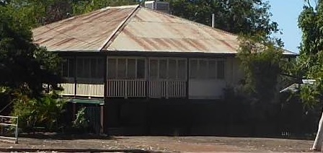

NORTH OF CORINDA AERODROME
F Battery’s one remaining 3 inch AA gun and its accompanying .50 machine gun was directly north of the aerodrome’s 09 degree magnetic airstrip on grid reference of 245 869 as per sheet 8157 (Edition 1) Charters Towers.

G BATTERY
I have no precise locations of these four AA guns. I have been advised there was one AA gun located near Florence’s Dairy on Scrubby Creek. This is a logical location as it is on a direct line along the length of the 056 degree runway from the south west. It also would cover the RDF (Radio Direction Finding) tower near what was Dave Parker’s Dairy. I have also been advised that a second AA gun was located near the Red Knob around to the south west. The third and fourth guns were further around in the southern sector to form a ring around Charters Towers.

THE DUMMY ANTI AIRCRAFT GUN
The Americans installed a wooden AA gun on the slope of Buckland Hills. It was in plain view. It had a barbed wire fence around it covered in white calico to make it really stand out from the air. It was unmanned. My brother Jim and I often took our shanghais (catapults) and a pocket full of stones for ammunition to this dummy and sat beside it waiting for the Jap bombers to arrive so we could have a go at them. Fortunately for us they never came. Unfortunately for us our parents found what we were doing. Punishment was delivered on the spot. Jim said afterwards whilst we were still smarting from the strap “Bugger the Japs.” I agreed. We never went back again. We weren’t frightened of the Japs. We knew our big brother Gilbert with his veteran mates of the 7th Division AIF back from the Middle East would beat the Japs, but Dad’s strap was a different and painful proposition altogether.

GUNNERY PRACTICE - LIVE FIRING
At 1PM on Monday and again the same night every week, gunnery practice was conducted by the AA guns and .50 machine guns. The guns fired live rounds during the afternoon and again at night. We had a grandstand view with our direct line of sight to the 3 inch gun located just below the college tennis court and the .50 behind our back fence. “Our” gun fired directly over our house westwards and high over Buckland Hills. The shells burst with a loud “pock” and a puff of black smoke. Night firing was even more spectacular with a long tongue of flame erupting from the muzzle followed by the red flash and “pock” as the shells exploded high in the sky. The .50 machine gun fired a short burst of three rounds during the day/night gunnery practice. Although we could not see the College’s other AA guns we certainly saw the shell bursts high in the sky. The remaining 5 AA guns would have fired from their positions in a safe direction away from town.

THE DOWNSIDE OF LIVE FIRING
Mother kept a spotlessly clean house. Unfortunately when the gun opened fire the muzzle blasts created shockwaves that made our old wooden house shake causing very fine dust to drift down from the ceiling much to Mother’s disgust. Our Kelpie dog upon hearing the first round fired took off at top speed. He would be away hiding in the hills for about three days before he gained enough courage to return home. Poor old fella was starving by then. As they say “He looked like a sheep herder’s dog, all ribs and balls”. We fed him up for the next few days until the guns fired again and the process was repeated. Definitely the fastest dog we ever owned.

Thornborough College: Its ornate plaster ceilings were ruined by the muzzle blast from the guns. Jessie Landsberg, a boarder during the war, told me that during classes when the guns fired bits of plaster from the ornate ceilings would fall down on them in the class room. Nobody was injured.

ROYAL AUSTRALIAN ARTILLERY (RAA)
The following information is by courtesy of Graham Mackenzie-Smith. The 32 LAA (Light Anti Aircraft) Battery arrived at Charters Towers from Melbourne in June 1942. It was renamed the 223 LAA Bty on the 12th July and moved to Cairns in August. In addition Graham has advised that the 64 AA SL Company arrived at Charters Towers from Sydney in June then moved onto Cairns in September. I do not know where they were actually located in the Charters Towers area.

SEARCH LIGHTS - CHARTERS TOWERS
E Battery arrived in Charters Towers with 70 men as they were one Platoon short.
Instead of 15 searchlights they only had 12. They formed a ring around Charters Towers. Their locations were as follows:
- Rules Pinnacle
- The Dump (the original dump near York Street)
- The Cemetery
- The Racecourse
- Milchester Creek, east of Charters Towers
- Whites Gully, west of F Gun’s grid reference covering the approach to the 09 degree strip
- Thornborough College
- Carlyon Creek, the north approach to the 056 degree strip
- The Pipeline (the town water supply pipe line from the Weir, Burdekin River)
- Featherby Wall
- Broughton
- Sandy Creek

One night each week there was searchlight practice. An unlit aircraft used to fly over and drone around Charters Towers for about one hour whilst the searchlights would try to illuminate it. Our family and neighbours used to sit outside watching the searchlights probing around the sky. The closest searchlight to us was on the college grounds. We could not see its actual position for the buildings and trees only its white beam into the sky. Once, to our delight, it actually illuminated the aircraft. Claude Risdale’s family living out on Sandy Creek had a great view of the searchlights on Featherby Wall and Sandy Creek and another further to the SW probing the sky for their target. Claude told me once the three lights fixed onto the aircraft and really lit it up.

My brother Jim, two years older than me, who passed away recently and I have been blessed with very retentive memories. We had spent many hours together pooling our boyhood memories and experiences of the period 1942 to 1945 which were exciting times for us boys.

FLIGHT PATH
I once wrote about Lissner Park being directly under the flight path of the southern end of the north-south 09 degree airstrip. This was disputed as incorrect, as in the opinion of this particular person the flight path was well to the east of Lissner Park. There is a photo of the southern landing approach of the 09 degree strip. In the foreground of this photo is Lissner Park. By placing a ruler exactly along the centre line of the 09 degree strip and extending this line out through the foreground, it can be clearly seen to bisect through the centre of Lissner Park.

OLYMPIA THEATRE
I also once wrote about the open air Olympia Theatre in Gill Street. I described aircraft coming in on final to the southern end of the 09 degree strip would come directly over head and very occasionally an aircraft would attempt to blot out the screen with its landing lights. I saw it happen one night with my father. Other people have confirmed they also remembered the screen being blotted out for a few seconds. Jim was luckier than me as he witnessed it twice on separate occasions. Had the photo I mentioned above included the Olympia Theatre further south, the ruler’s extended line would cover this theatre.

Again this was disputed by a person who insisted the Olympia Theatre was not on the flight path and therefore no aircraft on final approach could have flown directly over it. As for the occasional aircraft plotting out the open air screen he claimed it would be impossible to do so.

Recently I read an excerpt by a Donald Englund who served with the US 319 Bomb Squadron, 90th Bomb Group flying B24 Liberator heavy bombers. I quote “We spent several days there (Charters Towers) while the aircrew of Captain Holmes practiced night take offs and landings. We were able to see a movie and while at the movie we sat in the open air and were situated so we were in the flight path of our planes and we could see them go over head to the airstrip. It was a chance to eat at a restaurant etc”. He goes on to say “Holmes crew must have benefited from the experience since they always made it safely home from the missions they flew”.

I apologise for including the last two paragraphs regarding FLIGHT PATH and the OLYMPIA THEATRE as they have nothing to do with the AA guns but they certainly vindicate me.

Yours faithfully,

John P. Jewell OAM

