Disaster:
Amazing photo shows great detail. The pilot at low level had no control over his aircraft. It arrowly misses a crowd gathered for the air show and slams into four buildings. One can only imagine the horror of the occupants inside those buildings.
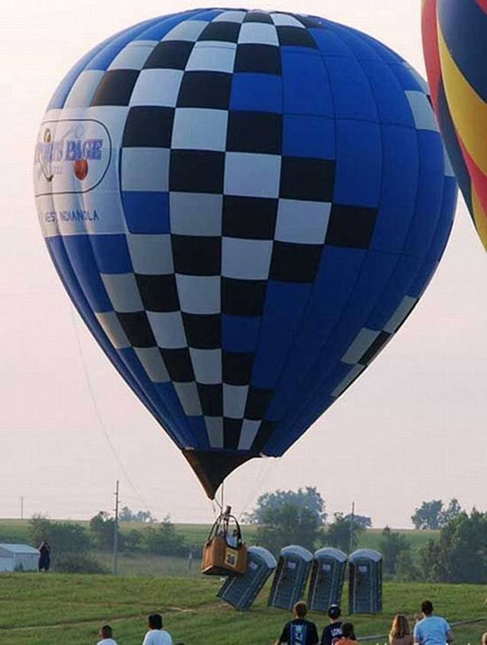

It probably scared the crap out of them.

