THE DIGGERS IN NEW GUINEA

This summary of John Hill’s service in the South Pacific naturally focuses on the air war. But it would be a significant oversight to not mention the ground campaign in New Guinea during this same period. The amazing fight between the Australian and Japanese forces over the rugged New Guinea terrain saved Port Moresby as a base of air operations. Although sometimes seeming disconnected, the air and ground operations in New Guinea were planned and carried out together. And the combined ground and air campaign eventually drove the Japanese off the island. The below material is taken from the books by Brune (Ref 1,2 ) and McAulay (Ref 3). The latter is especially significant, as Brune exclusively deals with the ground campaign with barely a reference to air operations, but McAulay does a credible job of interspersing air and ground events. Both books are very ground-centric regarding results, however, with little credit being given to air operations’ effects on Japanese troops, supplies, morale, and other factors impacting the campaign. [Perhaps this is making up for lost time, since until relatively recently, even the Australians failed to properly credit their own incredible New Guinea contribution.]

Setting the Stage

The defeat of the U.S. forces in the Philippines under MacArthur, and the withdrawal of the remnants to Australia have been well documented (). The collection of 20,000 or so U.S. personnel in Australia at that time, mostly not ready for combat, included John Hill’s diverted 27th Bomb Group. By early 1942, the Japanese were in New Britain and New Guinea and were conducting air raids on Australian coastal towns. Based on these rapid Japanese advancements in the theater, the primary objective of the Allied forces in the area was the defense of Australia. It took awhile for the military command structure between MacArthur and Australian General Blamey and the organization of forces to be sorted out, but by the Summer of 1942 the Allied defensive line was pushed out to New Guinea.

The Kokoda Trail, June-November 1942

The Australian forces (nicknamed Diggers) had established operations at Port Moresby and other spots in New Guinea, and with the influx of U.S. forces, defense plans were being drawn up. The following excerpt from describes the situation from the American perspective (map added for clarity).

The prospect General MacArthur faced in Australia was none too heartening. Japanese conquest of the Netherlands East Indies had placed enemy bombers within easy range of northwestern Australia, where Darwin had been under recurrent attack for almost a month. The occupation of Rabaul in January had been followed by air attacks on Australian posts along the upper coast of eastern New Guinea, and there on the night of 7/8 March Japanese landing parties had moved ashore to occupy Lae and Salamaua on the Huon Gulf. This move brought the enemy within 200 miles by air of Port Moresby, chief Australian outpost in New Guinea, which had experienced its first air attack early in February and would soon be the victim of repeated raids staged through Lae and Salamaua. Fortunately, the land approaches to Port Moresby were guarded by well nigh impenetrable jungles and the alpine reaches of the Owen Stanley Mountains. Even so, when the enemy infantry pushed inland toward the Australian mining center of Wan, 150 miles above Port Moresby, some saw in the move a step toward Port Moresby itself. Allied intelligence dismissed the idea, but no one discounted the serious threat of an amphibious assault designed to give the Japanese complete control of New Guinea.

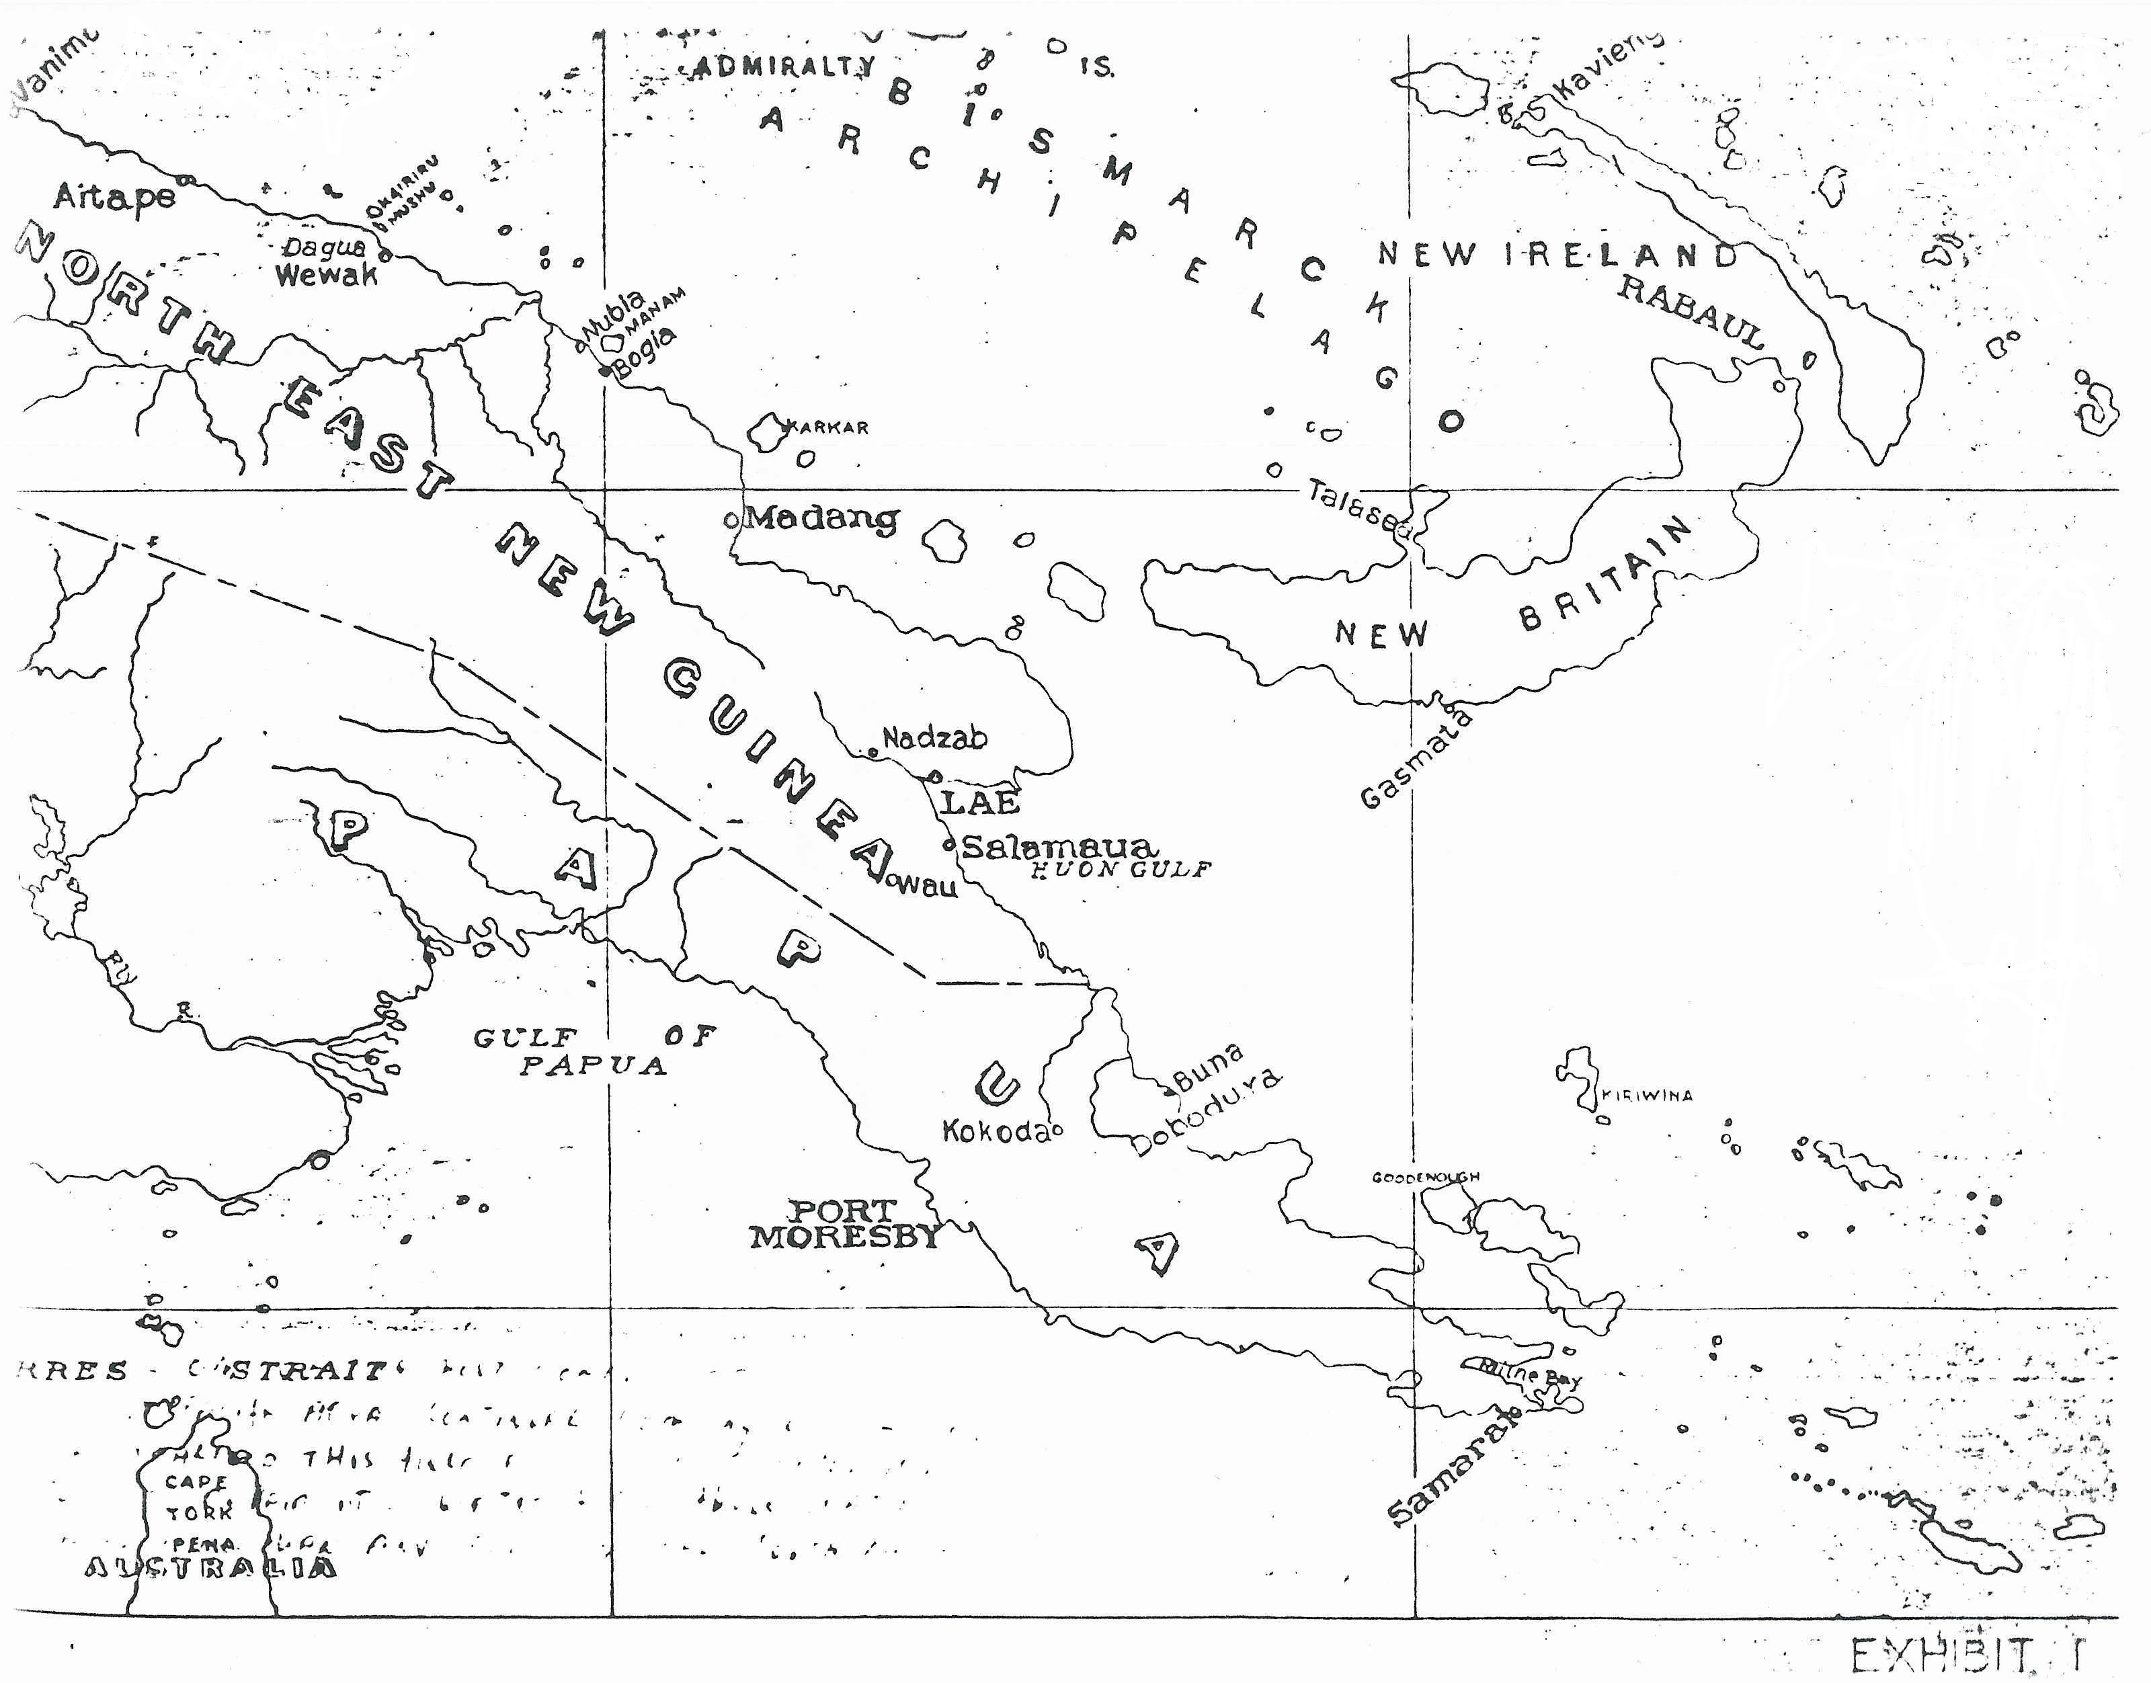

A conquest of New Guinea would have removed the last land barrier guarding the northern approaches to Australia. Though the Japanese plan of war had not included an invasion of Australia, Allied planners now were forced to accept such an eventuality as not only possible but even perhaps probable. Early in March, the Australian chiefs of staff concluded that an attempt on Port Moresby might be expected before the end of the month and an effort to occupy Darwin early in April. In Washington one, though not all, of the advisory committees of the Combined Chiefs of Staff felt that the enemy might attempt at least the occupation of such points on the mainland as Darwin, Wyndham, and perhaps Townsville. And so once again, as so frequently during that winter and spring, the question of a reallocation of forces had come under consideration…

The Australians decided to strengthen the Port Moresby garrison by assigning the 49th, 53rd and 39th Battalions of Australian Militia to upgrade the strength of the 30th Brigade. These deployments started 3 January [U.S. air operations out of Moresby commenced 1 April]. These Battalions were under-trained and under-supplied and graded F by the Australian’s own grading standards, even though they were in the most exposed position. The 7th Division of Australian Imperial Forces (AIF, the regular army) was recently returned from the Middle East and was battle-tested, but was initially held back. On 17 April, Brigadier Porter was assigned as a Brigade Commander and began to address the appalling conditions of the unit, including inadequate leadership and inadequate air forces. Even so, Port Moresby likely would have fallen to Japanese amphibious assault had not the Battle of the Coral Sea taken place on 7 May and halted the Japanese Navy offensive. We should remember that, to this point in the war, the Japanese were undefeated in battle, and were considered masters of jungle warfare in all aspects from leadership to equipment.

On the heels of this victory (Coral Sea), Allied planners recommended a more offensive posture, including the establishment of an air base in the Buna-Dobodura area on the North coast. Therefore on 29 June, the Australians decided to occupy Kokoda and its airfield for future protection of Dobodura and ordered a rifle company from the 39th Battalion over the Kokoda Trail. This started a campaign plagued by a pattern of poor intelligence and the disregard of good intelligence, with MacArthur’s staff at the forefront. In early July, units moved out, assisted by native “fuzzy wuzzy” porters, after plans for an air drop of supplies was cancelled. About the same time, the Japanese 17th Army received orders from Imperial Headquarters to proceed with a reconnaissance of the mountain crossing to Port Moresby.

It is hard to appreciate the conditions faced on the Kokoda Trail (or Track as the Australians say) during this campaign. The Track today is a popular 5-12 day trekking adventure for the reasonably physically fit; but in 1942 it was a muddy, hot/cold, malaria-infested, oxygen-deprived, uncertain footing climb of almost 9,000 feet with a 70 lb pack on the Digger’s back. The 3-4 ft wide track climbed 25 miles out of Moresby to Owens’ Corner and then down a slippery track to Uberi. It was a day’s march from Uberi to Ioribaiwa, up a razorback spur on the Imita Ridge, up a collection of roots, logs and mud known as the “Golden Stairs”, across a fast-flowing stream and up another ridge. From there, several steep ridge climbs and river crossings (via a log pole), a 1,700 ft descent, and a 700 ft climb (required coming and going) to the village of Efogi, and a steep 1,800 ft descent to Kagi. The trail then climbed 3,000 ft in 5 miles, close to an area called “The
Gap” through which aircraft flew on missions to either side of the island. Next came a 3,000 ft drop over 2 miles, so steep one had to hold on to vines and bushes to reach Eora Creek and on the West heights, Isurava. From there it was a downward track with numerous obstacles to the oppressive heat of Kokoda.

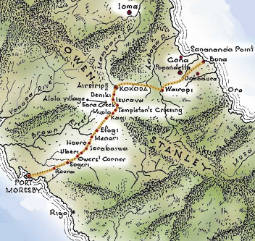

By the middle of July, the Digger forces were being committed piecemeal up the Kokoda track and advance units were East of Kokoda in monitoring positions. Contact with the Japanese was made and several skirmishes took place, often in the dark. On 29 July, the Japanese began their attack on entrenched Digger positions at Kokoda. In a day of desperate fighting, the larger Japanese force enveloped the Diggers, killed their commander Lt. Col. Owen, and despite numerous casualties, forced the Diggers to move back toward Deniki. [This was the same day as the infamous U.S. A-24 attack on Buna involving John Hill]. Early in August, two events shaped the Japanese forces that would be committed to Kokoda, the shuffling of forces to meet the emergency of the U.S. attack at Guadacanal, and the decision to attack the Allied base going up at Milne Bay. On 8 August, the 39th Battalion began moving back out of Deniki to attack Kokoda. Over several days, pockets of fighters moved back and forth destroying machine gun nests, stumbling on ambushes, exchanging friendly fire, carrying out wounded, and learning the fluid nature of jungle warfare the hard way. The battle line eventually moved back to Deniki and the Japanese continued their attack with superior numbers (but fewer rations as a result of Allied attacks on their shipping).

At this point in the battle, units from the regular Australian army (AIF) began arriving in New Guinea to reinforce the Militia. The AIF was told they would face only 1,200 Japanese and they were to attack and take back Kokoda, but as they started up the track they realized how horribly wrong the intelligence was about the terrain and the status of the conflict. The Militia they were to reinforce was now desperately digging in around Isurava, and Digger units scattered by the fighting kept arriving in torrential rain. Supply problems continued for both combatant armies, with shortages of food, blankets, and other necessities. On the Digger side, as Militia wounded made it to lower points on the track, their shocking physical condition encouraged the officers to move AIF troops farther forward.

Japanese attacks on Isurava commenced 26 August with the typical encircling maneuvers. This action saw the integration of the AIF forces with the Militia forces, and in general the coordination went well. Attacks and counterattacks occurred all over the Isurava area, which generated a high casualty rate and the awarding of the first medals for bravery on the Australian side, including Corporal McCallum who shot at least 40 Japanese at close range. The nightmare of building stretchers from native materials in the rain and carrying out the wounded was repeated over and over. It is believed that 29 August, a day in which the Japanese attacked repeatedly and used up much of its strength, may have been the high water mark. Had they broken through at that point, it was not clear an acceptable defense could have been established before Port Moresby. Even so, the battered Diggers were forced to fight a delaying action in reasonably good order back to Eora Creek.

On 31 August, the Japanese began attacking at Eora Creek and the Diggers commenced a number of counterattacks to slow the progress. The Allied Headquarters in Australia continued to be ignorant of the real situation and couldn’t understand why the Japanese pressed on toward Port Moresby after they had captured Kokoda airfield. A Digger Battalion held back a Japanese attack on the night of 3 September at Templeton’s Crossing, but the next day discovered phone lines in the foliage indicating the enemy had moved past them. A withdrawal to Myola was under extreme duress with the Japanese following only a few yards away. At this point, both the 53rd and 39th Battalions, having fought and bled so magnificently (especially the 39th), were relieved and sent back down the trail. The Diggers inflicted very high casualties on the Japanese in repulsing attacks at Myola and Efogi.

Menari was evacuated on 8 September and the Japanese held the high ground. A savage attack there had very nearly destroyed Brigade Headquarters, and afterwards the area became know as “Butcher’s Hill”. This was another of those engagements that bled the Japanese severely and impacted their ability to continue the pace of attack. Fighting continued at Nauro and then the Japanese attacked Ioribaiwa on 12 September. Digger reinforcements arrived and they were able to hold the Japanese in check for over a week of intense fighting, before the decision was made to move back to a more defensible position at Imita Ridge. From their position at Ioribaiwa, the Japanese could see the lights of Port Moresby 26 miles away. And at Port Moresby, General MacArthur, Kenney and others had arrived to discuss the campaign, and a new Brigade of AIF with fine green uniforms began to arrive. On 24 September, some of the Japanese Headquarters’ unit began to withdraw to the East. The rest of the Japanese dug in at several locations and the Diggers began preparing their forces for an attack on the enemy positions. On 28 September, Lt. Gen Rowell, in charge of Australian forces in the campaign was (unjustly) relieved, and the Australian counteroffensive began.

The Japanese fought a retreating action until putting up stout resistance at Templeton’s Crossing on 12 October. They were eventually dislodged after a few days. In the next two weeks, the Australians pushed them gradually back up the Kokoda track. The Diggers reached Kokoda on 2 November, which allowed air supply at the airfield, and greatly relieved the logistics burden. Attacks moved on to Gorari and by 15 November, the Japanese force was effectively destroyed. It had been a campaign that few believed possible, owing to the impossibility of the terrain and the superiority of the Japanese forces. A poorly-trained Australian Militia force was sent up over the mountain, where it hung on against great odds and uncertain senior leadership, and exacted a price too terrible for the Japanese to finish what they started. The Diggers got little recognition and more politically-adept military people claimed the credit, but they had destroyed the myth of Japanese invincibility and had saved their homeland.

Milne Bay, June-September 1942

At about the time of the initiation of the Kokoda campaign, it was determined that a force was needed to defend the proposed airbase at Milne Bay, on the southeastern tip of the island. Although the position was strategic, the topography was quite different than the Kokoda track, with a coastal section of swamps and jungle leading up to a heavily timbered mountain range, and seemingly incessant rain. The site selected for the airfield was the Lever Brothers coconut plantation, and American engineers began the first airstrip on 28 June. The 7th Australian Militia Brigade began arriving on 11 July [Recall that Lt. Hill’s famous Buna mission in which he diverted to Milne Bay was on 29 July 1942]. RAAF P-40 Squadrons began arriving on 25 July, and Japanese air activity in the area began 4 August. The Japanese plan of attack was to assault Milne Bay at the same time the Kokoda force struck over the mountain range, and then for both forces to converge on Port Moresby with the Milne Bay force arriving by sea. Despite the inability to properly reconnoiter the objective, the Japanese launched their Milne Bay attack the night of 25 August.

The Japanese rolled in at Waga Waga beach and pushed back the closest Diggers, reportedly accompanied by atrocities against the natives and Diggers who got in the way. As they moved ashore, they established a sandbag beach head and hurriedly prepared for the RAAF attacks they knew would come at daylight. The attack of the P-40’s the next morning halted Japanese operations, destroyed landing barges and blew up ammunition stores. The pattern was quickly set – Australian air superiority severely limited Japanese operations during the day, and Japanese naval forces returned at night to support ground assaults up the tracks. All was confusion at night, but the Diggers had established a defense in depth and were well situated to defend the vital airstrips.

On the second night, the Japanese pushed forward with a coordinated tank and infantry attack, skillfully using the tank’s lights and tracers to identify Digger positions, and then infantry machine guns moving forward in the dark. British sticky bombs proved ineffective against the tanks because they were too hard to place and they didn’t work in the damp conditions anyway. In the confusion, various Digger Companies were cut off and withdrew via different routes to Motieau Creek. Three airstrips had been built at Milne Bay, and as the closest strip to the beach head (number 3) came under attack, the decision was made to deploy the RAAF aircraft to Port Moresby to save them for operations the next day. However, the move was premature as Australian and American halftracks stopped a three wave charge by the Japanese, and forced them to give up the attack on airstrip 3 by dawn.

The Japanese rested on 28 August, but the Australians committed some experienced AIF troops to the battle and went on the offensive the following morning. They made good progress and retook several positions, setting up a new defensive line for the expected counterattack that night. It was thrust and parry for several days, but by 3 September, the Diggers stepped up the offensive, and began using flanking attacks around the edge of the Japanese lines for the first time. On 4 September, Corporal John French won the second Victoria Cross of the New Guinea campaign by wiping out 3 machine gun nests with hand grenades (he was killed). By 5 September the Japanese had had enough and began withdrawing. This Australian victory actually preceded the Kokoda campaign as a statement that the Japanese were beatable, and demonstrated the best use to date of combined ground and air resources. Curiously, Maj Gen Clowes who fought the Milne Bay battle was not given further command, this coming on the heels of the firing of Potts and Rowell who were the two most responsible for the Kokoda success.

Gona-Buna-Sanananda, November 1942 – January 1943

In late September 1942, a three pronged attack on the Japanese Gona-Buna-Sanananda beachhead was planned to permit a firm Allied hold on New Guinea. One approach was to be back along the Kokoda track to Gona, the second was a thrust East of Kokoda to Buna (assigned to the Americans), and the third was a sea/land assault from Milne Bay toward Buna. The beachhead in question was a 15 mile strip of native villages, coconut palm groves and a mixture of swamps, jungle and kunai grass. The Digger approach on Gona soon determined the Japanese had prepared a superb network of slit trenches, log berms, and overlapping fire lines for machine guns that revealed no weaknesses. Hemmed in by the swamp, initial attacks resulted in high casualties, and the already undermanned units continued to wither. The addition of mortar fire, air bombing, and then artillery on 24 November still resulted in the 4th failed Gona attack on the next day.

The Americans were having no better luck at Buna. The inexperienced troops were getting a baptism in jungle warfare and were showing no progress and less initiative. In fact, when MacArthur offered Australian General Blamey the 41st American Division as a beachhead reinforcement, Blamey declined. By 29 November, spirited attacks were being made on the Gona Mission but the defenses were too good. The Japanese snipers were concentrating on Bren machine gun operators and officers and they went down at an alarming rate. It was only a combination of determination and heroism that allowed the Diggers to fight their way to Gona Creek by the start of December. On 7 December, reinforcements and new tactics (rushing the enemy at the end of an artillery barrage) began to punch a few holes in the defenses.

Meanwhile the Americans were bogged down in the approach to Buna - mostly National Guards troops from Wisconsin and Michigan, they were totally overmatched by the environment and the Japanese defense. MacArthur sent Gen Eichelberger to relieve Gen Harding, and Gen Blamey sent some Digger troops to assist, deploying some light Stuart tanks on the 15th. The forces slugged forward, taking casualties, but by the end of December had taken two of the three area objectives in Buna. (The addition of an ammonal charge initiated by a grenade was quite effective if it could be dropped into a slit trench). The third area, however, was a well designed series of bunkers, and the killing continued at a rapid rate until Buna was cleared on 2 January. Attention now turned to the Sanananda beachhead between Gona and Buna.

The half mile of Sanananda beaches was prepared with interconnected pillboxes, trenches, snipers and camouflaged positions. Units of the 126th American Regiment were brought in to reinforce the depleted Diggers, but achieved little in a week and a half. Additional Australian Militia units were brought in and the attacks continued. However, more theater-level decisions were being made that affected the outcome. On 13 January, the Japanese ordered the evacuation of Guadacanal, and by extension, realized the present New Guinea position was also hopeless. The Sanananda commader was told to evacuate his troops North to Salamaua and Lae, and by 20 January the remnant Japanese forces had been destroyed. This campaign was over, sadly followed by MacArthur and other American generals claiming credit for successes the Australians were chiefly responsible for. The focus now shifted to Salamaua and Lae and points Northeast. [John Hill flew missions for 6 more months before being relieved and returning to the U.S.]

References.
- Brune, Peter, Those Ragged Bloody Heroes, Allen & Unwin, Crows Nest NSW Australia, 2005.
- Brune, Peter, A Bastard of a Place, The Australians in Papua, Allen & Unwin, Crows Nest NSW Australia, 2004
- McAulay, Lex, Blood and Iron, The Battle for Kokoda 1942, Arrow Books, Milsons Point NSW Australia, 1992.
- McDonald, Neil and Brune, Peter, 200 Shots, Damien Parer and George Silk with the Australians at war in New Guinea, Allen & Unwin, Crows Nest NSW Australia, 2004.

