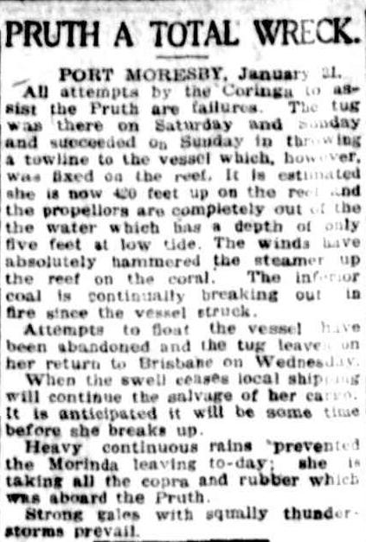

PORT MORESBY, January 21. All attempts by the Coringa to assist the Pruth are failures. The tug was there on Saturday and Sunday and succeeded on Sunday in throwing a towline to the vessel which, however, was fixed on the reef. It is estimated she is now 420 feet up on the reef and the propellers are completely out of the the water which has a depth of only five feet at low tide. The winds have absolutely hammered the steamer up the reef on the coral. The inferior coal is continually breaking out in fire since the vessel struck. Attempts to float the vessel have been abandoned and the tug leaves on her return to Brisbane on Wednesday. When the swell ceases local shipping will continue the salvage of her cargo. It is anticipated it will be some time before she breaks up. Heavy continuous rains prevented the Morinda leaving today; she is taking all the copra and rubber which was aboard the Pruth. Strong gales with squally thunder-storms prevail.

